P
AND
Q
OR

AND

R
OR

AND

S

P
AND

Q
NotNot
OR

AND
Not
R

P
AND

OR

Q
NotNot
AND
NotNot
R

P
AND
OR

Q

AND
R

P
AND
OR

Q
AND

R

P
OR

NOTNot

OR

Q
OR

NOT

R

EX2:
- S = 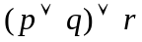
P
OR

OR

Q

R
- S =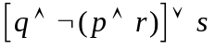
AND
NOT
P
AND
OR

Q

R

S

